Trade of Metal Fabrication
Module 2: | Thermal Processes
Unit 9: | Tungsten Arc Gas Shielded Welding (Stainless Steel)
 | Phase 2

Table of Contents
List of Figures 4
List of Tables 4
Document Release History 5
Module 2 – Thermal Processes 6
Unit 9 – Tungsten Arc Gas Shielded Welding (Stainless Steel) 6
Learning Outcome: 6
Key Learning Points: 6
Training Resources: 7
Key Learning Points Code: 7
TIG MMA Square Wave 8
Electrode Protrusion 8
Preparation of Electrode Ends 9
Tungsten Arc Gas Shielded Welding 10
Arc Starting 10
Applications 11
Depositing Straight Runs 13
Striking and Breaking the Arc 15
Fusion with Filler Metal 15
Self Assessment 16
Index 17

List of Figures
Figure 1 - 250 a.c./d.c. TIG MMA Square Wave with OC/CV Feeder 8
Figure 2 - Electrode Protrusion 8
Figure 3 - Preparation of Electrode Ends 9
Figure 4 - Characteristics of a.c. and d.c. Arcs 10
Figure 5 - Tungsten Arc Gas Shielded Welding Applications 12
Figure 6 - Fusion with Filler metal 15

List of Tables

Document Release History
Date | Version | Comments
02/11/06 | First draft
13/12/13 | SOLAS transfer

Module 2 – Thermal Processes

Unit 9 – Tungsten Arc Gas Shielded Welding (Stainless Steel)
Duration – 16 Hours

Learning Outcome:
By the end of this unit each apprentice will be able to:
- Safely set up and weld using a TIG/TAGs welding plant on stainless steel
- Select and prepare a tungsten electrode
- Select and adjust welding current to suit stainless steel
- Identify and correct weld defects
- Weld a series of exercises on stainless steel
- State the safety precautions to be observed when TIG welding

Key Learning Points:
Rk Sk | Weld techniques.
Rk Sk | Tungsten selection and preparation – tungsten protrusion (stick out).
Rk Sk | Plant settings and adjustments.
Rk | Weld defects (e.g. porosity, weld profile, lack of penetration).
Rk Sk | Torch and rod manipulation.
Rk | Purging of roots.
Rk Sk | Speed of travel when welding.
Rk Sk | Distortion Control (chills).
Rk Sk | Post weld cleaning.
H | Safety procedures and precautions – safe work area, P.P.E.
P | Communication, work planning/quality.

Training Resources:
- Fabrication workshop facilities
- T.A.G. Weld plant and equipment, filler rods
- Welding booths and extractors
- Handouts and notes
- Safety clothing and equipment
- Materials as stated on exercises
- Examples of good and bad welds

Key Learning Points Code:
M = Maths D= Drawing RK = Related Knowledge Sc = Science
P = Personal Skills Sk = Skill H = Hazards

TIG MMA Square Wave
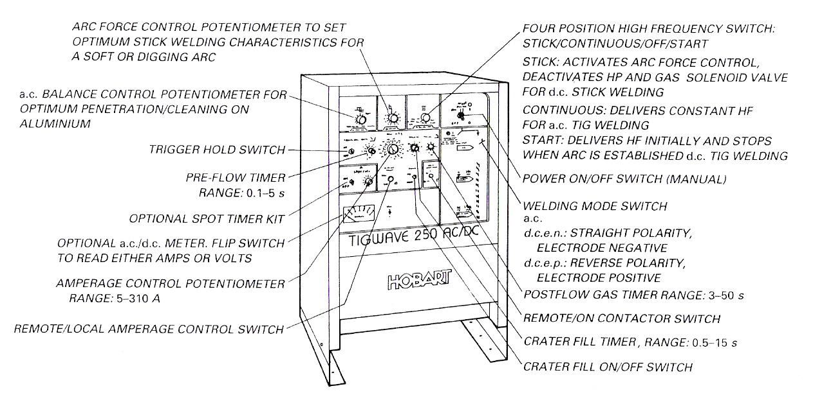
Figure 1 - 250 a.c./d.c. TIG MMA Square Wave

Available voltages: 230/380/415/500 a.c.
50 Hz OCV 80
Welding mode switch 5 310 A, a.c. or d.c.e.n., d.c.e.p.
Pre and post flow gas 250 A at 40° duty cycle
Balance control penetration/cleaning
Arc force control (soft or digging arc)

Electrode Protrusion
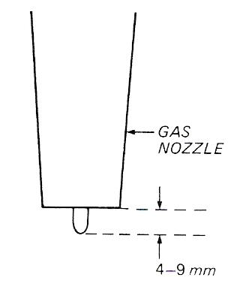
Figure 2 - Electrode Protrusion

No gas lens. In awkward places protrusion can be increased. Gas shield must cover area being welded.

Preparation of Electrode Ends
- The working tip of the electrode should be ground to provide a point.
For this purpose a silicon carbide wheel, grade 0 to M 60 grain, should be kept and not used for other work.
- For D.C. welding a sharp point is desirable. The length of the taper for electrode sizes up to 1/8˝ (3.0 mm) should be about three times the diameter. For electrode sizes over 1/8" (3.0 mm) it should be about twice the diameter.
- For A.C. welding a 'balled' point is desirable. The end should be pre-chamfered at an angle of about 45° leaving a blunt point of a diameter about half that of the electrode diameter. Before use an arc should be struck on scrap parent metal to 'ball' the end of the electrode.

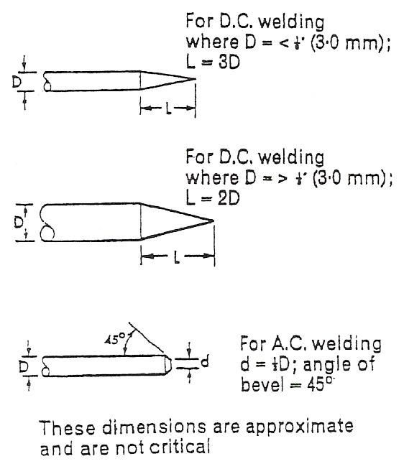
Figure 3 - Preparation of Electrode Ends

Tungsten Arc Gas Shielded Welding
This process is a method of welding whereby an electric arc is maintained between a virtually non-consumable tungsten electrode, in an atmosphere of pure argon, with or without small additions of other beneficial gases. The gas shield prevents weld metal contamination by the atmosphere. The surface of aluminium alloys is covered by a refractory high melting point film of oxide which must be removed before a satisfactory weld can be made. A filler wire may also be added at the leading edge of the molten pool to form the weld. It is one of the characteristics of an alternating current arc that it removes this tenacious oxide during the welding process. Figure 4 shows the characteristics of a.c. and d.c. arcs.

Arc Starting
To initiate the arc for welding the two most common methods are:

High Frequency (H.F.) A series of high-voltage high-frequency sparks are superimposed on the main welding current so that, at the press of a switch, they pass from the tungsten to the work and so ionise the air gap (break down the resistance) and allow the welding current to create an arc. This avoids touching the plate with the tungsten and avoids contamination. The H.F. may be continuous for a.c., and for d.c. used only when the arc has been extinguished.

Surge Injection is another method of arc starting which also uses a high-voltage high-frequency spark.

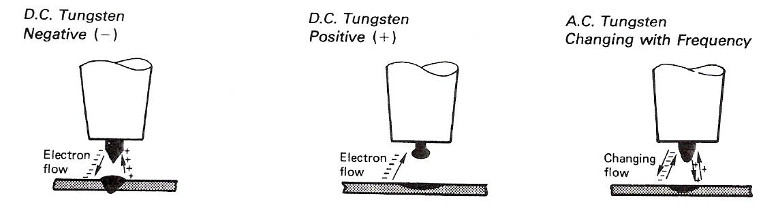
Figure 4 - Characteristics of a.c. and d.c. Arcs

Heat distribution | Plate Electrode ⅔  ⅓ | Plate Electrode ⅓  ⅔ | Equally distributed with a 50 c/s supply, the electrode is positive for 1/100 sec, then negative for 1/100 sec.
Electrode composition | 2% thoriated tungsten ground to a sharp point approx.60°. | - | 1 % zirconiated tungsten ground to 45° with a blunt end.
Applications  Welding carbon and stainless steels, titanium, nickel, copper and respective alloys.  Explanation of characteristics  d.c. negative tungsten  The electrode remains cool but the oxide film is unbroken (hence no good for aluminium). Resulting weld is narrow with deep penetration resulting from bombardment of the plate by the electrons. |  | Seldom used and never for thick materials  d.c. positive tungsten  The oxide film on the plate is lifted and disrupted by the electron flow from the plate. Overheating of the electrode with tungsten inclusions and wide shallow weld results. (Not advised for welding any thick materials). | Used for welding aluminium and magnesium and their alloys.  a.c. tungsten changing polarity  The oxide film is disrupted and removed during the time the electrode is positive, causing the electrode to overheat. This is followed by a period when the electrode becomes negative and cools down but with no oxide removal but with ⅔ of the heat in the plate (most suitable for aluminium).

Applications
The T.A.G.S. welding process is used where high-quality neat-looking welds are required, and is economical for thicknesses up to 6 mm. For thicknesses greater than 6 mm, M.A.G.S. welding is usually used or other metal arc welding processes. Root runs in pipe joints either with or without fusible inserts are put in using T.A.G.S. welding because the penetration can be controlled to give a smooth flush finish. After inspection the remainder of the joint is completed using quicker methods. Figure 5 shows the electrode shapes used.
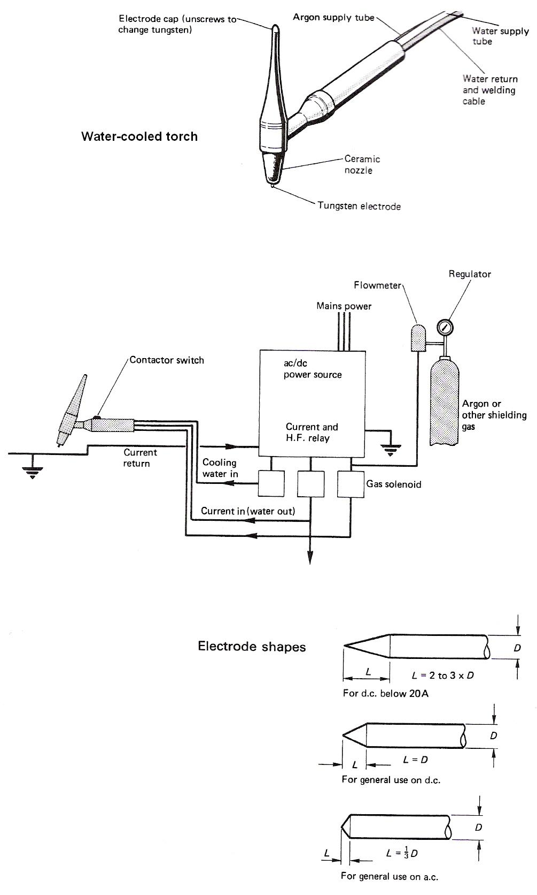
Figure 5 - Tungsten Arc Gas Shielded Welding Applications

Depositing Straight Runs
Example Procedure EP43
- Establish small pool of molten metal near right-hand edge of sheet, holding torch vertical.
- Decrease the electrode angle to 70°-80°.
- Hold filler rod in left hand, between the fingers and thumb, pointing at the front edge of the molten pool and at an angle of 10°-20°.
- Allow the arc heat to melt a little metal from the end of the filler rod and start the leftwards movement of the torch.
- Always keep the filler rod end within the argon shroud, making contact with the weld pool but not with the electrode when adding filler metal.
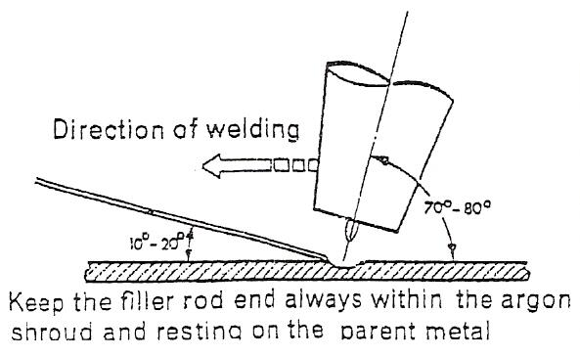
- Steady addition of filler metal gives even deposition. The rate of travel leftwards should be coordinated with melting of filler rod to control size of bead and extent of penetration.
Repeat the procedure until separate straight runs of even shape and width can be produced at will with a consistent arc length of less than 1/8˝ (3.0 mm). Do not allow parent metal to become over-heated.
Material | 16 s.w.g. (1.5 mm) stainless steel, 1 off, min. 4˝ (10.0 cm) x 6˝ (15.0 cm).
Preparation | Clean surface.
Assembly | Support sheet in flat position, long axis, and parallel to bench front.
Electrode | 1/16˝ (1.5 mm)
Argon | 5-8 ft.³/hr.
Current | 50-70 amperes
Filler | 1/16˝ (1.5 mm)
Example Procedure EP 44
Material | 16 s.w.g. (1.5 mm) aluminium, 1 off, min. 4˝ (10.0 cm) x 8˝ (20.0 cm).
Preparation | Surface cleaned immediately before welding.
Assembly | as for EP 43.
Electrode | 3/32˝ (2.5 mm)
Argon | 8-12 ft.³/hr.
Current | 50-75 amperes
Filler | 3/32˝ (2.5 mm)

- Commence welding at the right-hand edge of the sheet.
- The torch and filler rod should be held in the same manner as for EP43, taking great care that the filler rod end is kept within the argon shroud.
- The weld pool will not be so clear as when welding corrosion-resistant steel but the slight oxide film will be disintegrated and removed so that it causes no difficulty in observing the weld pool.
- Co-ordinate the leftwards movement and the addition of filler metal to build up a reinforcement bead of even height and width.

Visual Examination
Examine deposited beads and note any variations in width or height of run or depth of fusion into parent metal. These may be caused by variations in arc length, rate of travel, rate of addition of filler metal. Assess causes and take appropriate corrective action.
The reverse side of the sheet should indicate traces of penetration without any burn-through.

Striking and Breaking the Arc

Fusion with Filler Metal
Having mastered the basic skills using D.C. equipment for the welding of stainless steel (or mild steel), practice should be obtained using A.C. equipment for the welding of aluminium.

It will be necessary to make adjustments to the rate of torch travel and the rate of filler metal feed. There will be observable differences in arc characteristics.

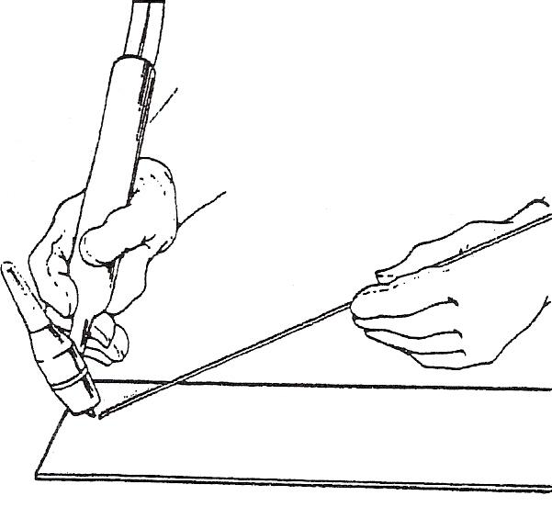
Figure 6 - Fusion with Filler metal

Self Assessment
Questions on Background Notes – Module 2.Unit 9

No Suggested Questions and Answers.

Index

E
Electrode Protrusion, 9
P
Preparation of Electrode Ends, 11
S
Striking and Breaking the Arc, 17
Fusion with Filler Metal, 17
T
TIG MMA Square Wave with OC/CV Feeder, 9
Tungsten Arc Gas Shielded Welding, 12
Applications, 13
Arc Starting, 12
Depositing Straight Runs, 15

